**Assignment Cover Sheet**

|  |  |  |
| --- | --- | --- |
| **Qualification** | | **Module Number and Title** |
| HD in Computing and Software Engineering | | Web Application Development |
| **Student Name & No.** | | **Assessor** |
| K.K. Dimalsha Sachinthani  CL/HDCSE/CMU/115/180 | | **Ms. Lanka Leelarathna** |
| **Hand out date** | | **Submission Date** |
| 2024-08-04 | | 2024-10-05 |
| **Assessment type**  WRIT1 | **Duration/Length of**  **Assessment Type**  3000 words | **Weighting of Assessment**  100% |

|  |  |
| --- | --- |
| **Learner declaration** | |
| I certify that the work submitted for this assignment is my own and research sources are fully acknowledged. | |
| |  |  |  |  | | --- | --- | --- | --- | | **Marks Awarded** | | | | | First assessor | |  | | | IV marks | |  | | | Agreed grade | |  | | | Signature of the assessor |  | Date |  | |

**Feedback Form**

**International College of Business & Technology**

**Module: Web Application Development - Cse5009 – Coursework**

**Student:** K.K. Dimalsha Sachinthani - CL/HDCSE/CMU/115/180

**Assessor:**

**Assignment:**

**Strong features of your work:**

**Areas for improvement:**

**Marks Awarded:**

**Task 1**

1. **Plan and design for the web application**

**1.1 Analyzing Similar Web Systems**

In this section will conduct competitor research by identifying and evaluating a few restaurant websites that target a similar audience to "The Gallery Café." These websites are Colombo-based restaurants, or global platforms that offer online ordering, reservation systems, and promotional features. The evaluation will focus on Design and User Experience, Functionality, Performance and Usability, and Security.

* Competitor Research

The following restaurant websites have been chosen for analysis:

* Ministry of Crab (Colombo-based restaurant with global recognition)
* Rare at Residence (Fine dining in Colombo)
* Uber Eats (Food delivery service with pre-ordering functionality)
* OpenTable (Global restaurant reservation platform)

**1.1.1 Ministry of Crab**

Ministry of Crab is a renowned seafood restaurant in Colombo, celebrated for its focus on serving high-quality, fresh crab dishes. Known globally, the restaurant combines a luxurious dining experience with a commitment to sustainability and local produce, attracting both local and international visitors.

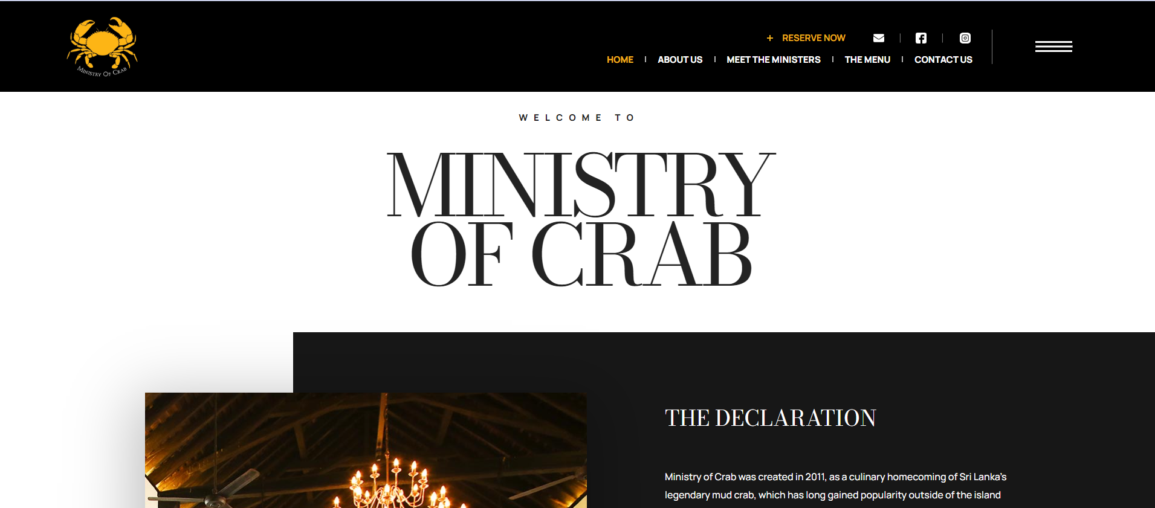

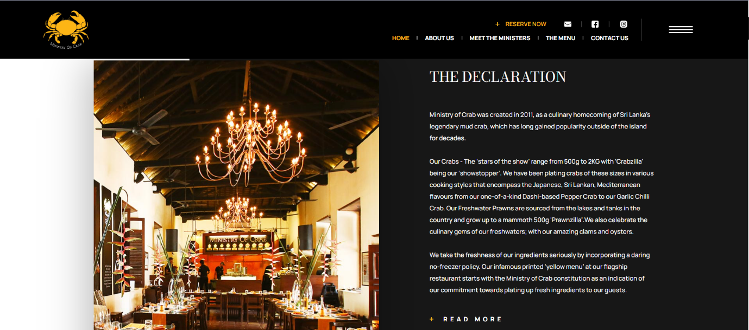

* Design and User Experience

Ministry of Crab’s website presents a sleek, professional design with high-quality images of its signature dishes. The homepage showcases the restaurant’s ambiance, accolades, and contact information. The site uses elegant typography and a dark color palette, creating a luxurious dining appeal. Navigation is minimal but clear, with a top menu offering links to the menu, locations, and reservations.

* Functionality

The website offers reservation features via a third-party integration (ResDiary), allowing users to book tables online. There is no online ordering or pre-ordering functionality, as the focus is on fine dining. Customers can search through different menus but there are no filters for dietary preferences or cuisine types.

* Performance and Usability

The website is highly responsive, loading quickly on both desktop and mobile devices. Navigation is easy and straightforward with no performance lags, ensuring a smooth user experience.

* Security

The Ministry of Crab uses HTTPS to encrypt data, ensuring a secure browsing experience. However, since there is no online payment or login system, its security features focus more on ensuring safe browsing.

**1.1.2 Rare at Residence**

Rare at Residence is an upscale fine dining restaurant located in Colombo, offering a curated menu that emphasizes contemporary Sri Lankan cuisine with a modern twist. It provides an intimate and elegant dining experience, making it a popular choice for discerning diners.

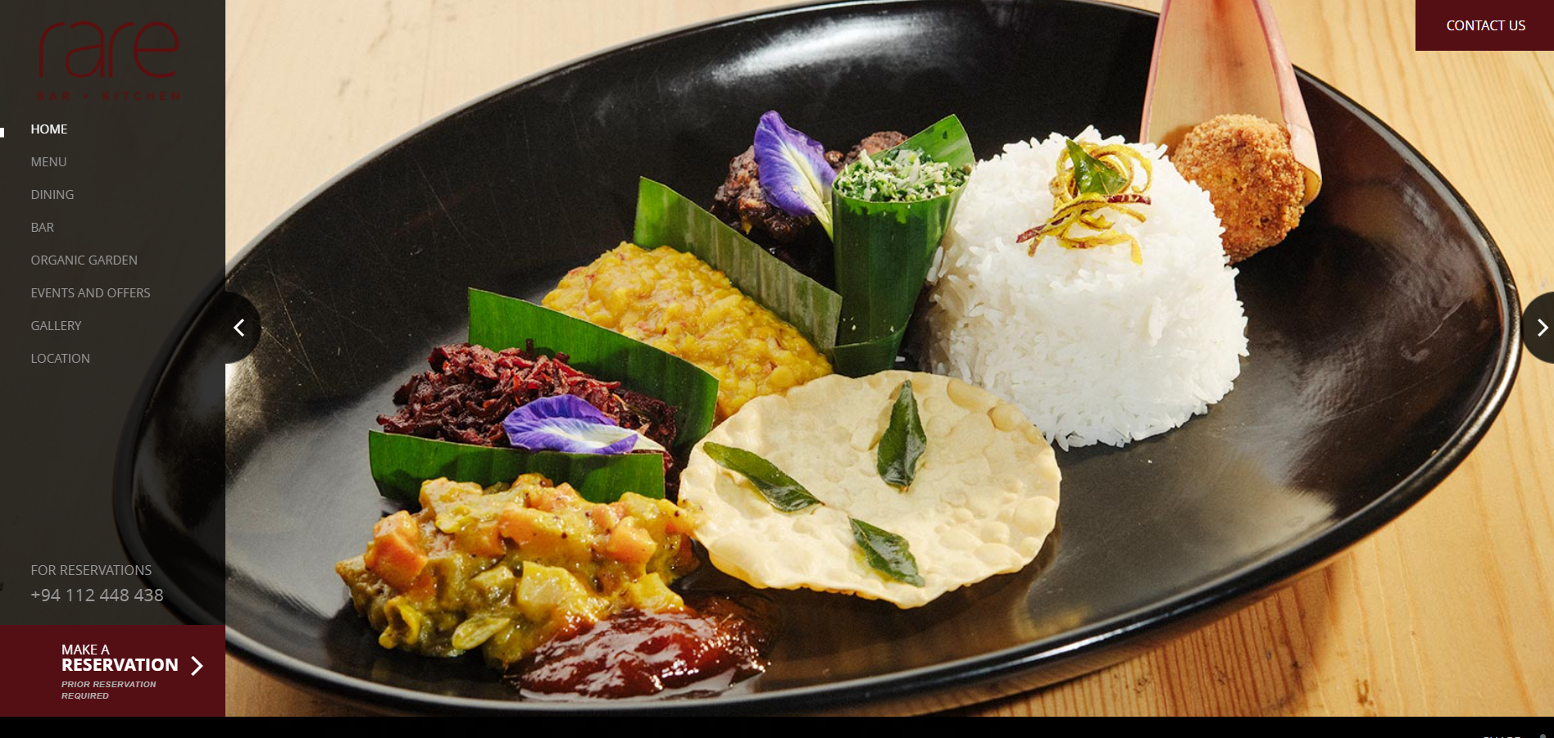

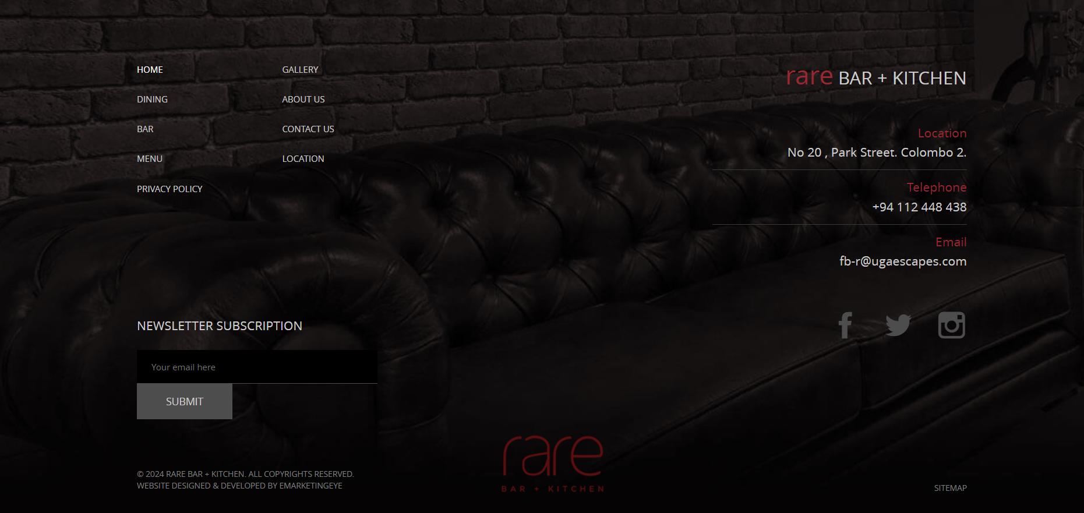

* Design and User Experience

Rare at Residence emphasizes a luxurious, fine dining experience with its visually appealing design. High-quality images of dishes and the restaurant's setting are prominently displayed on the homepage. The navigation is clean and simple, with clear categories such as Menu, Gallery, and Reservations.

* Functionality

The reservation system is integrated via ResDiary, providing users the ability to book tables online. Unlike Ministry of Crab, Rare also includes a detailed menu section with descriptions of dishes, but it lacks a pre-ordering system. There is no dedicated search function to filter through menus by cuisine type or dietary restrictions.

* Performance and Usability

The website performs well on various devices, ensuring a mobile-friendly experience. It is well-optimized for fast loading times, and the navigation is simple enough for users to browse through the site without confusion.

* Security

Rare at Residence uses HTTPS to ensure secure communication between the user and the server. There is no user login system, so security is focused on securing the reservation process.

**1.1.3 Uber Eats**

Uber Eats is a global food delivery service that allows users to order food online from a wide range of restaurants. With a user-friendly interface, it offers features like pre-ordering, real-time tracking, and flexible delivery options, making it a convenient choice for customers seeking quick access to meals.

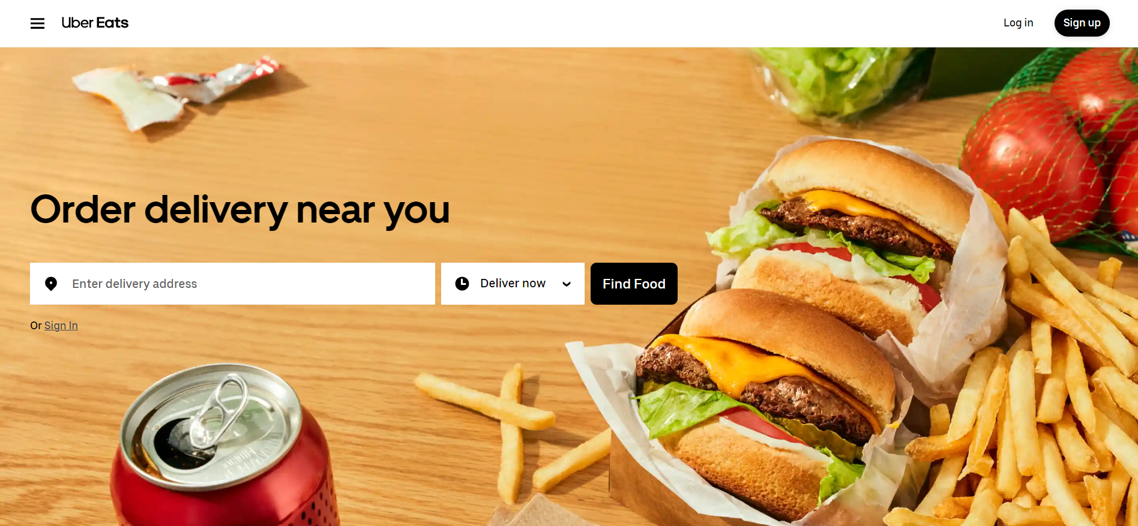

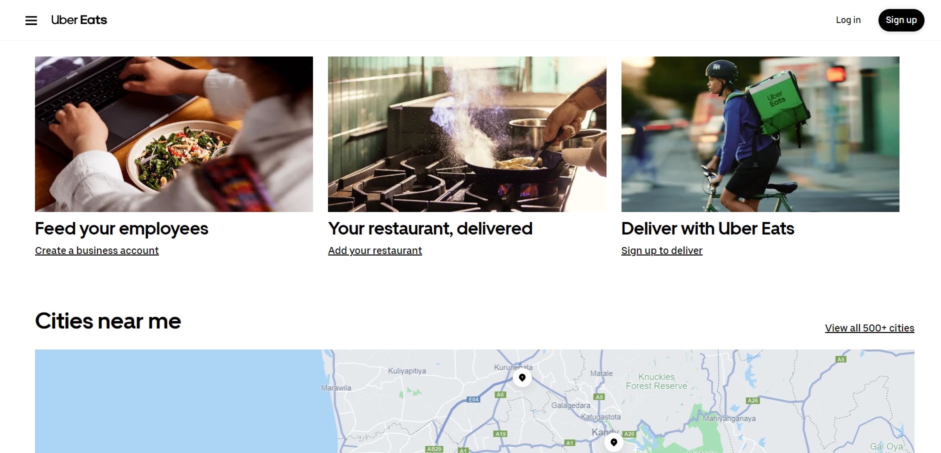

* Design and User Experience

Uber Eats prioritizes simplicity and functionality in its design. The homepage is geared toward action, with search bars and buttons prominently displayed for quick access to restaurants and food items. The app and website offer a visually clean and intuitive user experience, with user-friendly filters, and categorization based on cuisine types, price, and dietary preferences.

* Functionality

Uber Eats excels in functionality, providing pre-ordering capabilities, live order tracking, and delivery options. Customers can search for restaurants based on location, and cuisine types (Sri Lankan, Chinese, Italian, etc.), and filter through menu items. The platform also offers features like scheduled orders and integration with promotional discounts.

* Performance and Usability

The Uber Eats platform is optimized for both desktop and mobile, providing a fast and smooth experience. The app’s responsive design ensures that users can navigate seamlessly on smaller devices. Orders can be placed quickly, with minimal clicks required to finalize transactions.

* Security

Uber Eats employs industry-standard encryption to protect sensitive data like user credentials and payment information. It offers secure login via username/password or social media accounts and supports two-factor authentication for added security.

**1.1.4 OpenTable**

OpenTable is a leading online restaurant reservation platform that enables users to easily book tables at restaurants worldwide. It offers real-time availability, user reviews, and dining recommendations, providing a convenient solution for those looking to secure reservations quickly and efficiently.

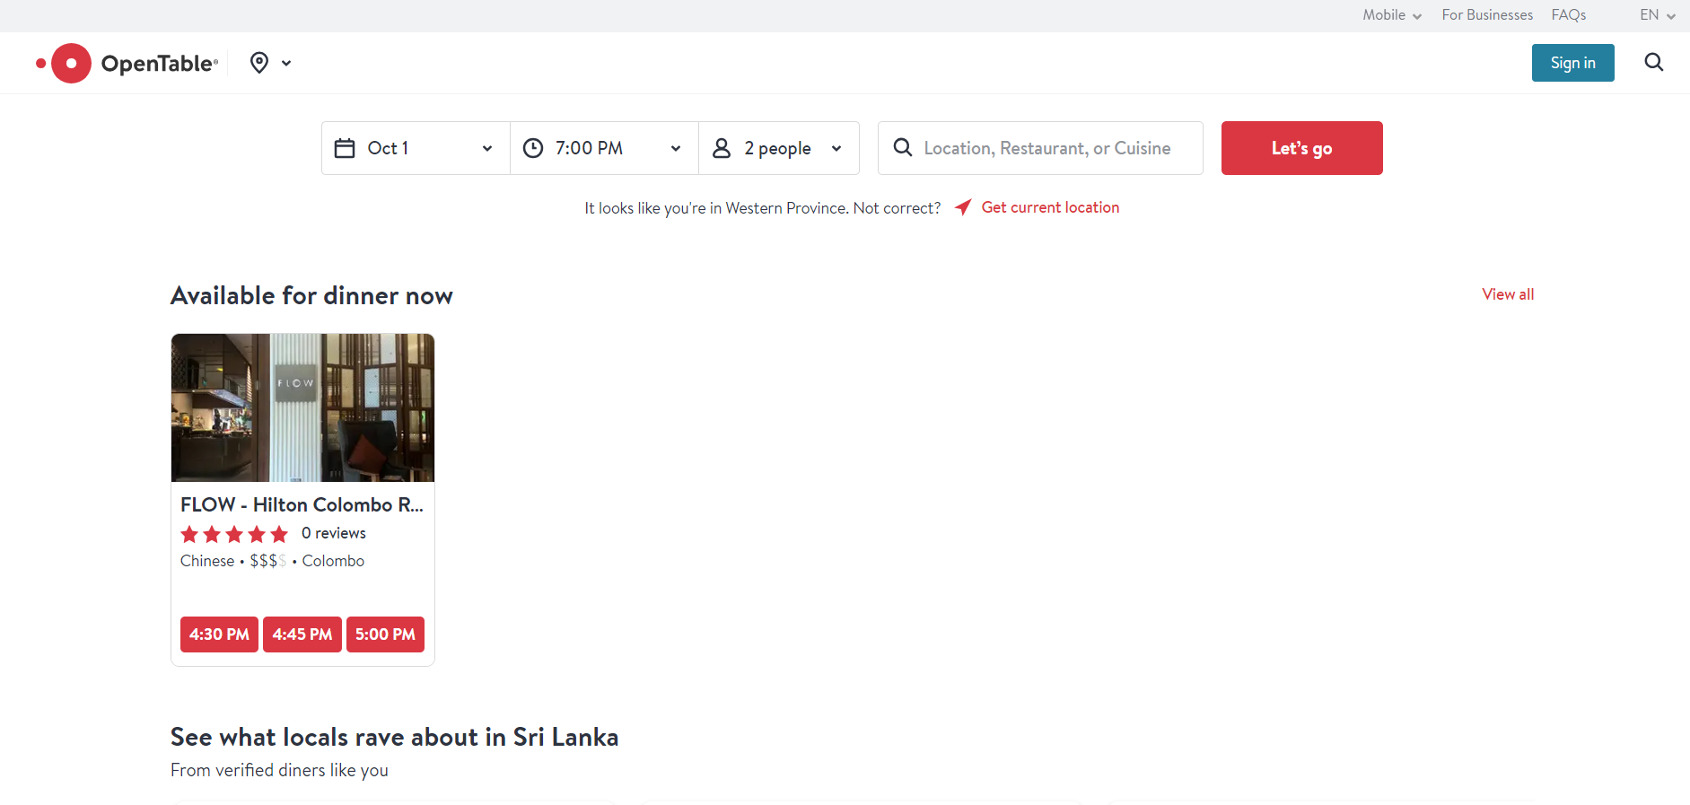

* Design and User Experience

OpenTable features a simple, modern interface designed for ease of use. The homepage immediately directs users to search for restaurant reservations by location, date, and time. Images of popular restaurants, including ratings and user reviews, make it easy to browse.

* Functionality

OpenTable’s primary feature is its reservation system, which allows users to book tables in real-time. Restaurants can display availability, promotions, and special events, all integrated with the booking process. OpenTable does not offer pre-ordering services, as it focuses solely on reservations. Users can search for restaurants based on cuisine types, location, or dining preferences.

* Performance and Usability

OpenTable’s platform is optimized for speed and ease of use across all devices. Whether accessing the site via desktop or mobile, users are guided through the reservation process quickly. The site is responsive, and forms are easy to complete without unnecessary fields.

* Security

OpenTable uses robust encryption to secure customer information during reservation bookings. The system ensures that personal and financial data are protected, offering a secure login system and secure handling of payment information for pre-paid bookings.

**1.1.5 Comparison of Design Factors**

|  |  |  |  |  |
| --- | --- | --- | --- | --- |
| **Web site** | **Design & User Experience** | **Functionality** | **Performance & Usability** | **Security** |
| **Ministry of Crab** | Luxurious, sleek, with high-quality visuals | Reservation system integrated with ResDiary | Smooth, and responsive on both desktop and mobile | Basic security with HTTPS, no login or payment systems |
| **Rare at Residence** | Elegant design with emphasis on high-quality imagery | Reservation system integrated with ResDiary | Fast, mobile-friendly, with straightforward navigation | Secure reservations, uses HTTPS for safe browsing |
| **Uber Eats** | Simple, intuitive, focused on quick actions | Pre-ordering, live tracking, search by cuisine, filters, scheduled orders | Highly responsive and mobile-optimized, fast order processing | High level of security, encrypted transactions, two-factor authentication |
| **OpenTable** | Clean and modern, focused on search and reservation | Real-time table bookings, search by location and cuisine type | Fast, easy to navigate across devices, real-time reservation handling | Strong encryption, secure bookings, login system with data protection |

**SOFTWARE REQUIREMENT SPECIFICATIONS**

**1. Introduction**

**1.1 Purpose**

The current document, called the Software Requirements Specification (SRS), defines the basic requirements for creating a comprehensive database-driven website for The Gallery Café. Gallery Café is a Colombo institution dedicated to improving customer satisfaction through the use of cutting-edge technology. The website is designed to provide a seamless and engaging online experience with a range of features such as table reservations, food reservations, user registration and comprehensive restaurant details. The website will be a vital resource for enhancing company operations, increasing customer satisfaction, and expediting the ordering and reservation process.

**1.2 Scope**

With the ability to book a table, order food, register as a user and access comprehensive restaurant details, the website will provide an interactive platform for The Gallery Café. There will also be support for three categories of users: administrators, operators and customers.

**1.3 Definitions, abbreviations and abbreviations**

Administrator: A user with full rights to manage and control the site.

Operators: Booking and Reservation Managers and Audiences.

Customer: A customer with the ability to schedule a meal in advance, view restaurant details, and make a reservation.

Interface: User

User experience or UX

**2. Functional Requirements**

**2.1Enrollment of Users**  
Account Creation: Users must input their password, phone number, email address, and name in order to establish an account.  
Admin approval: When a new user registers, administrators have the option to examine, accept, or reject it.

**2.2 Verification of Users**Secure Login: With safeguards in place to stop unwanted access, registered users can log in safely with just their email address and password.

**2.3 Administration of Databases**  
User profiles: Safely store login credentials and user information.  
Reservation Data: Keep track of reservation details such the time, date, and number of seats.  
Pre-order Information: Keep track of pre-order information, such as food products and quantities.  
Content management: Take care of material on menus, occasions, sales, and specifics about restaurants.

**2.4 Features for Searching**  
Food Search: Using an intuitive search function, users can look for food by cuisine type, such as Chinese or Sri Lankan.

**2.5 Reservation for a Table**Online Reservation: By choosing the day, time, and number of guests, users can make reservations for tables online.  
Reservation Confirmation: After receiving confirmation of their reservation, users are free to make any necessary changes or cancellations.

**2.6 Placing an Advance Order**Ordering: Prior to their visit, patrons are able to place food orders.  
Order Management: Pre-orders can be seen, changed, or canceled by customers.

**2.7 Control Panel**  
Admins have the ability to add, modify, and remove user accounts.  
Content Management: Promotions, events, and cuisine details can be added, updated, or removed by administrators.  
Admins have the ability to inspect, confirm, amend, or cancel reservations.

**2.8 Error Handling**

**3. Non – Functional Requirements**

**3.1 Security**

Data Protection: Apps must use encryption and secure access restrictions to ensure the security and privacy of user data.

Authentication and authorization: To protect sensitive data, establish strong authentication procedures and role-based access controls.

**3.2 Performance**

Responsiveness: All users should be able to interact with the website quickly and easily with short loading times, making it responsive.

Scalability: Systems must be designed to support increasing data volumes and users without sacrificing functionality.

**3.3 Usability**

User-friendly interface: To ensure that users can easily access and use the website’s numerous features, the user interface must be easy to use and intuitive.

Accessibility: The website should work across a variety of browsers and be usable on desktops, tablets, and mobile devices.

**3.4 Credibility**

Availability: The website should ensure a high degree of uptime and low downtime, allowing users to have continuous access.

Failure recovery: To effectively manage unexpected problems, implement fault tolerance and error recovery procedures.

**3.5Sustainability**  
Code quality: To make maintenance and changes easier, the codebase has to be organized and documented.  
System Updates: To maintain the website up to date and functional, offer assistance for frequent updates and improvements.

**Conclusion**

This Software Requirements Specification (SRS) describes the elements and functionality required to create a feature-rich, database-driven website for The Gallery Café Online. It strives to improve customer experience, speed up operations and provide a useful platform for online booking and pre-ordering.

**1.2 UI Design**

**1.2.1 Site Map**

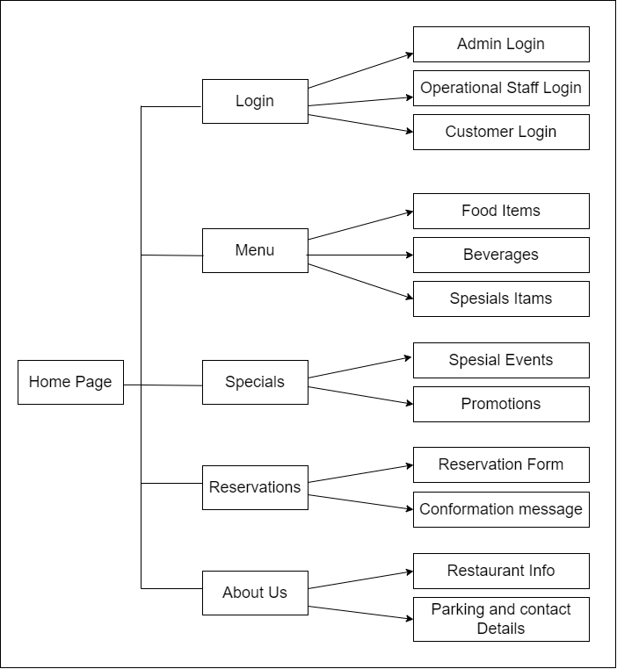

**1.2.2 Mockup Diagram**

* 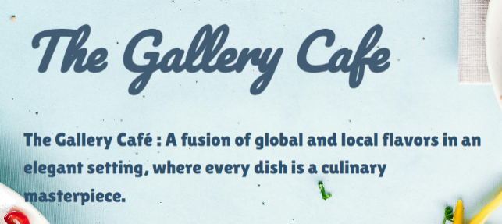**Colour selection**

Black, White, and Blue is a sophisticated color palette used in the UI/UX design of the Gallery Café website to create a stylish and professional online presence. This color scheme provides a more luxurious and welcoming experience for on-site visitors, while enhancing visual appeal and complementing the restaurant’s upscale ambience.

* **Home page – Main section**

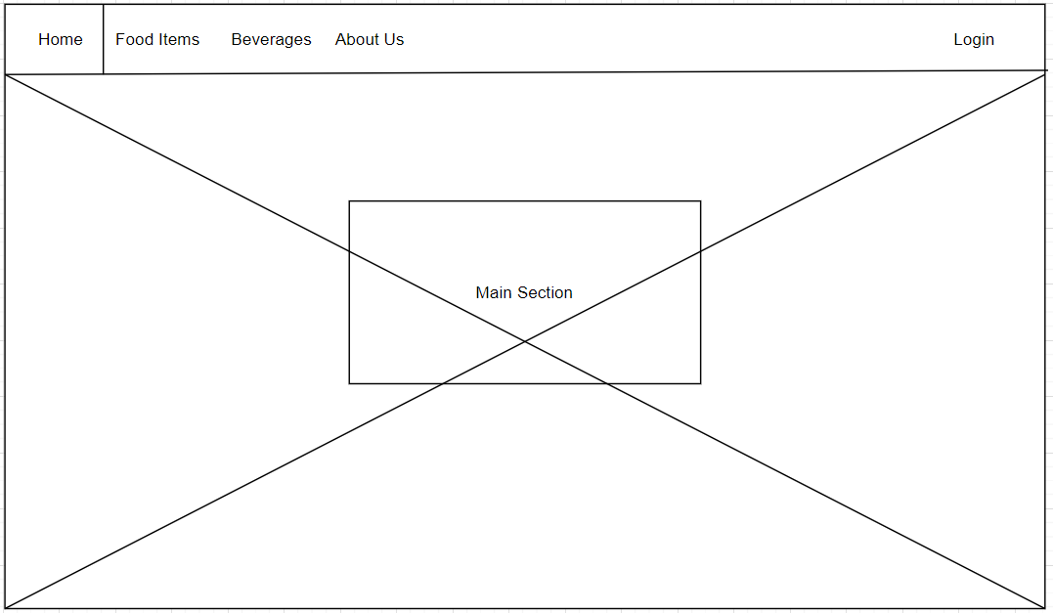The main section of the Gallery Cafe homepage provides an engaging overview of the restaurant, where guests are welcomed and set the stage for an amazing dining experience. Home, Menu, About, Reservations and Contact sections are all easily accessible via a simplified navigation bar in the header.

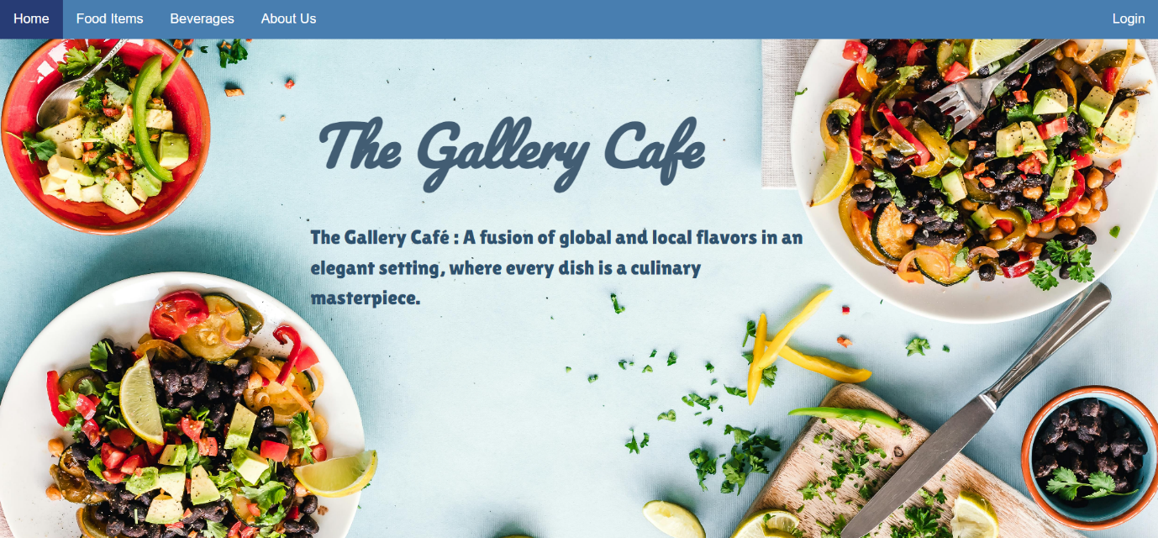

* **Home page – Menu section**

The Gallery Cafe website has a nice and well-organized menu section. It is divided into three parts, each with a brief description to facilitate visitors to explore various specialties. Menu items appear below the category image with their name, price, and brief description. Via it we can preorder and search different cuisines.

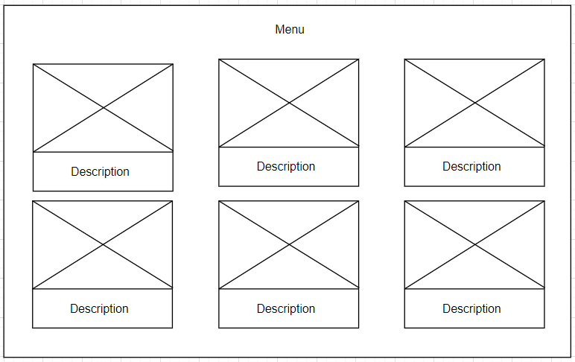

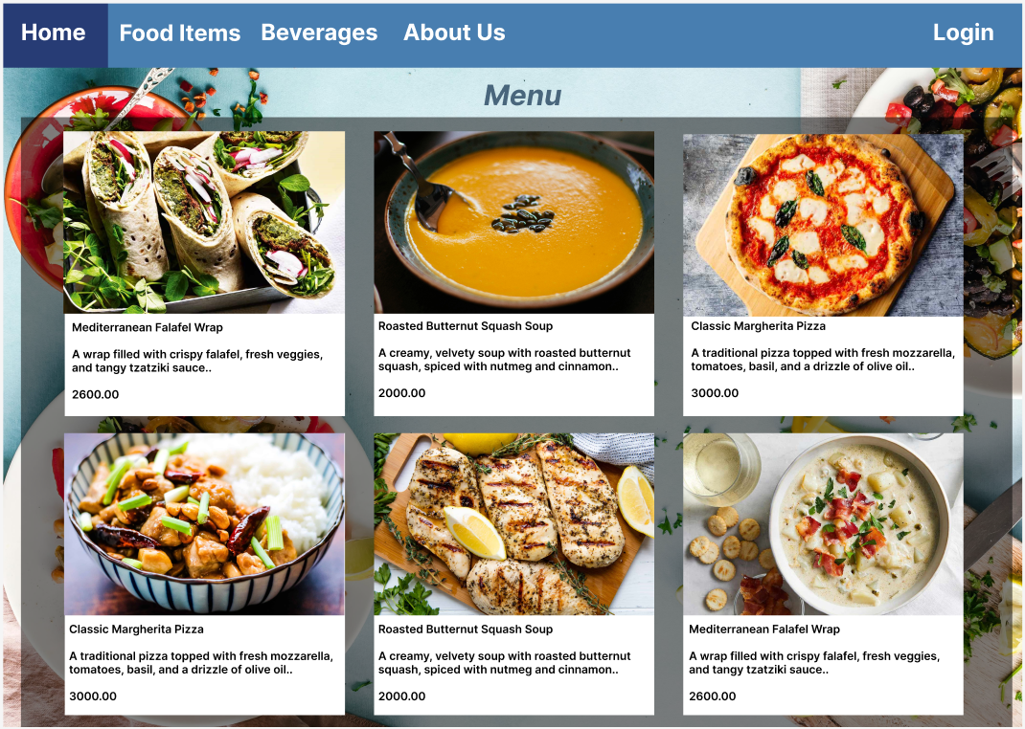

* **Home page – Login section**

The Gallery Café website features a streamlined and secure login section, designed to provide easy access for different user types. The login page is divided into three roles: Customers, Operational Staff, and Admins, each with its specific access privileges. After selecting the appropriate role, users can enter their credentials to access the relevant features of the website. The system ensures smooth navigation, allowing customers to manage their reservations and pre-orders, while operational staff and admins can handle backend operations efficiently.

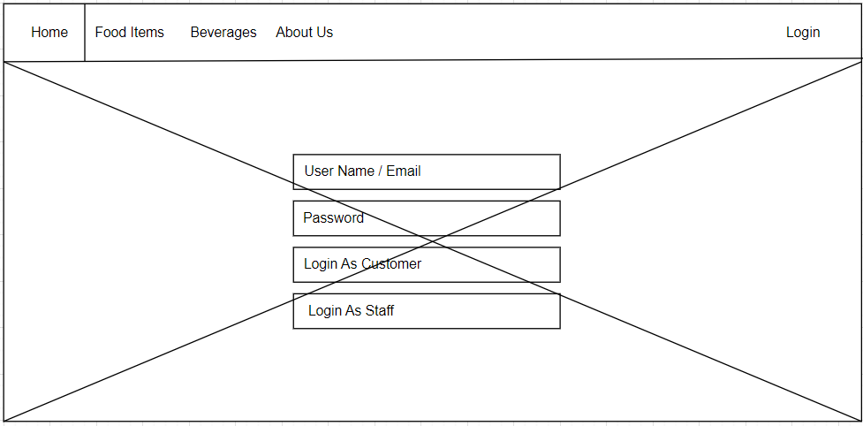

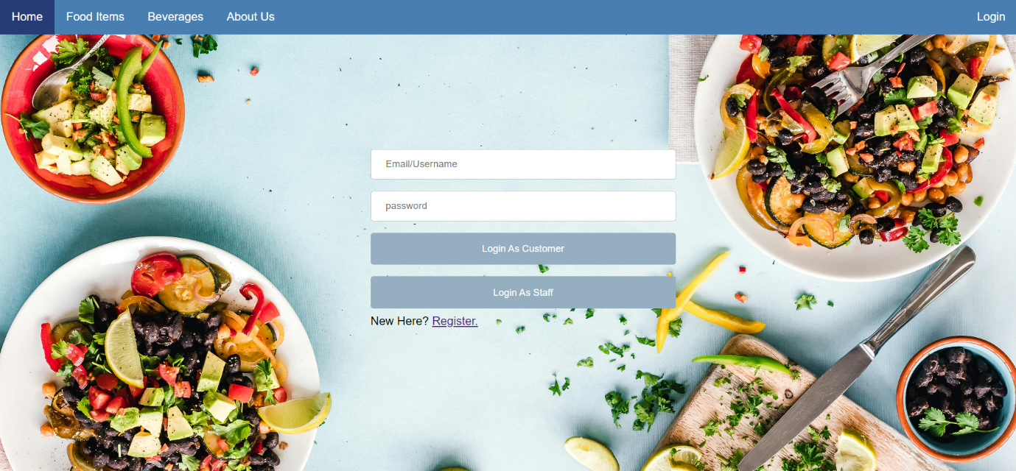

* **Home page – About section**

The "About Us" section of the Gallery Cafe homepage features an eye-catching layout that blends educational text with beautiful images. The "About" heading at the top provides a clear introduction to the section. The stunning image below the logo captures the atmosphere and appeal of the Gallery Cafe, allowing viewers to get a visual preview of what’s in store. The photos are accompanied by a concise yet warm statement that sums up the Gallery Cafe’s ethos, culinary philosophy, and dedication to excellent service.

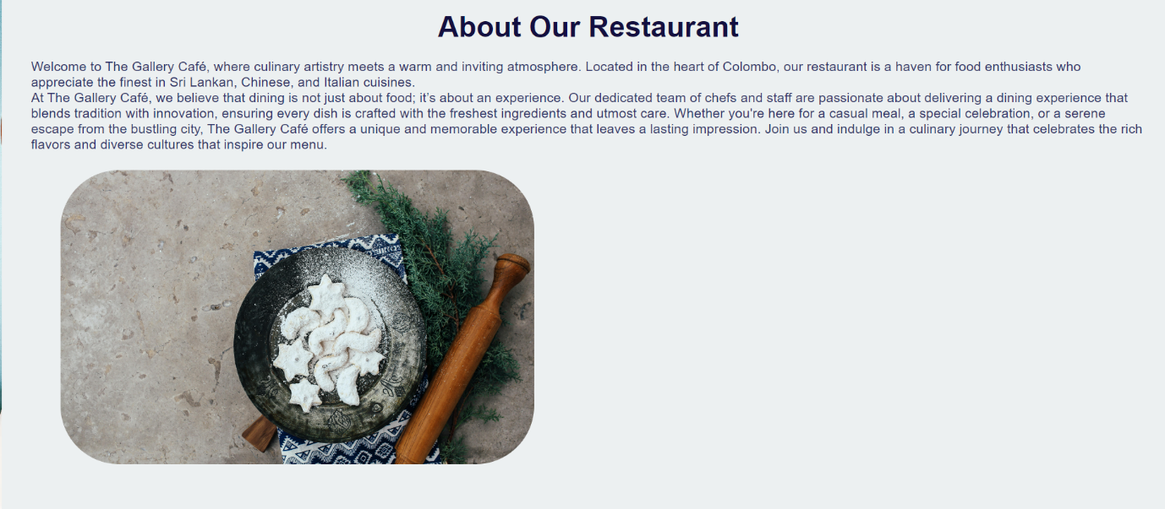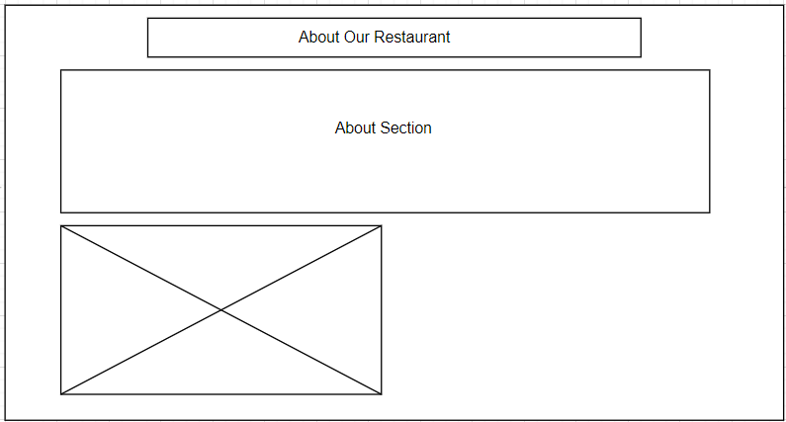

**Task 2**

**2. Implement a database-driven web application based on the given design**

**2.1 Front-End Language**

HTML (Hypertext Markup Language) and CSS (Cascading Style Sheets) are the fundamental building blocks for creating and designing websites. HTML defines the structure and content of web pages, organizing elements like headings, paragraphs, images, forms, and links. It provides the semantic framework that gives meaning to web content, ensuring that elements are properly categorized (MDN Web Docs, 2023). On the other hand, CSS controls the visual presentation of web pages, allowing developers to style and position HTML elements effectively. CSS is crucial for creating responsive and visually appealing websites, as it governs layout properties like color, fonts, spacing, and positioning. By using CSS, developers can design websites that are easy to maintain and update, separating content from presentation.

Two of the most powerful CSS layout methods are Flexbox and CSS Grid. Flexbox, short for “Flexible Box,” is a one-dimensional layout system that excels in aligning items in a single direction, either as rows or columns (MDN Web Docs, 2023). It is particularly useful for creating responsive and adaptive designs, where elements can shrink, expand, or be aligned flexibly. This makes it ideal for arranging navigation bars, aligning buttons, or distributing content evenly across a page. Meanwhile, CSS Grid offers a two-dimensional layout system, allowing content to be arranged both in rows and columns. It provides developers with a structured framework to create complex and organized web layouts, making it perfect for grid-based designs such as dashboards or image galleries.

JavaScript is a dynamic and essential programming language for modern web development, enabling interactive and dynamic features on web pages. It runs directly in the browser, allowing developers to create functionality like form validation, content updates, animations, and interactive user interfaces (JavaScript.info, 2023). JavaScript can also manipulate HTML and CSS in real-time, enabling users to interact with a page and see changes without needing to reload the page. This interactivity makes JavaScript indispensable for contemporary websites that require high levels of engagement, such as e-commerce platforms, social networks, or web applications.

The Bootstrap framework is a widely used front-end toolkit that simplifies the process of creating responsive and visually appealing web pages. Bootstrap provides a collection of pre-designed components, such as buttons, forms, modals, and navigation bars, that can be easily customized to match the website's style. It also includes a responsive grid system, ensuring that web pages look good on devices of any size (GetBootstrap, 2023). By using Bootstrap, developers can rapidly prototype and develop user interfaces without starting from scratch, while maintaining a consistent design language throughout the site.

**Eye-catching Design with Innovative ideas**

Create beautiful interactive layouts and functionality by using Bootstrap components and tools. Use custom CSS to deliver eye-catching images and animations that complement your restaurant's identity.

**2.1.1 Home Section Design for The Gallery Café Website**

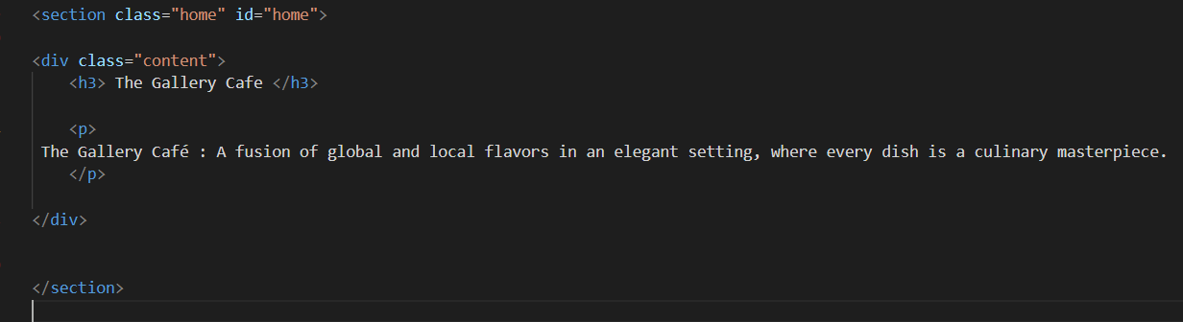

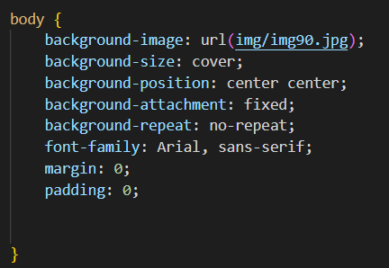

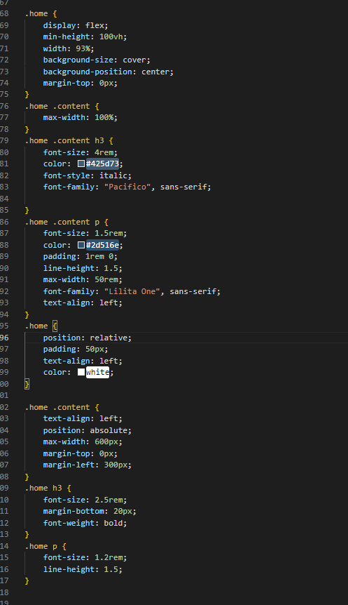

The Home Section of The Gallery Café website offers a visually engaging and user-friendly introduction to the restaurant's brand. The section leverages high-quality design elements to create a lasting first impression on visitors.

* **Large Background Image:**

The background image, img90.jpg, spans the entire viewport, offering a full-width high-resolution visual that sets the tone for the website. This image reflects the ambiance of the restaurant and helps to captivate the user from the moment they land on the homepage.

* **Engaging Hero Text:**

The hero section features a bold heading, "The Gallery Café," paired with a descriptive paragraph that introduces the restaurant as a blend of global and local flavors. The heading uses a large, custom font size (4rem) with a beautiful italic style to enhance elegance, while the paragraph text is smaller yet prominent, encouraging readability. The color contrast between the text and background ensures clarity, making the information stand out effectively.

* **Customizable Layout with Bootstrap:**

The layout is organized using CSS Flexbox and a responsive grid system, making the content adaptive across various screen sizes. This ensures that the website looks polished on both mobile and desktop devices, with spacing and alignment that prevent clutter. The flexible layout allows for easy navigation while maintaining a clean, minimalistic design.

* **Text Animation and Placement**:

The content of the home section, including the heading and paragraph, is positioned in the center-left of the viewport using absolute positioning. This ensures that the text remains clear and unobstructed, regardless of the screen size. The choice of fonts such as "Pacifico" and "Lilita One" gives the site a modern and inviting feel, while the text alignment to the left (text-align: left) creates a professional, easy-to-read format.

* **Effective Use of White Space:**

Adequate white space is provided around the text and between elements to keep the design clean and avoid overcrowding. This is achieved using CSS padding and margin properties, which enhance the readability and organization of content. The strategic use of white space helps visitors focus on the most important elements without distractions.

* **Mobile Responsiveness:**

The CSS ensures that the home section maintains a high degree of responsiveness. Elements like the background image and content adjust dynamically, making sure that the website maintains visual integrity across devices, providing a seamless experience for users, whether they're on a desktop or a mobile device.

**2.1.2 Navigation Menu Design for The Gallery Café Website**

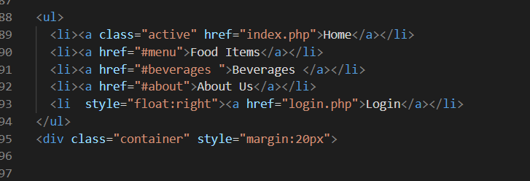

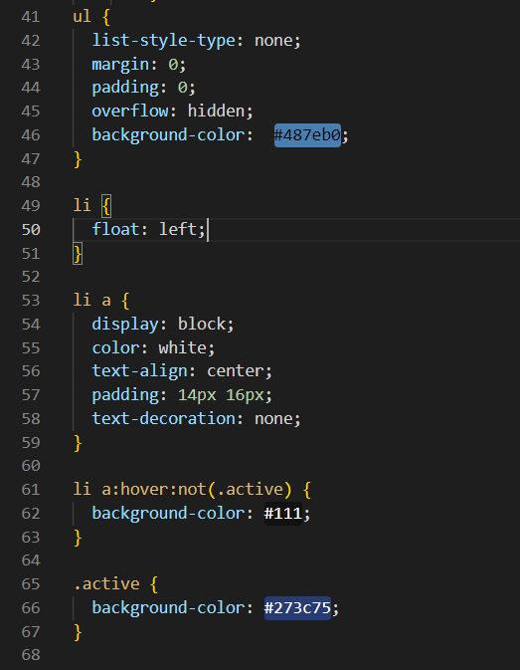

The Navigation Menu on The Gallery Café website is designed to provide visitors with a seamless browsing experience. The navigation is simple yet efficient, allowing users to easily access different sections of the website, such as food items, beverages, and login pages.

* **Clear and Well-Organized Structure: The navigation menu consists of five main items:**

Home, Food Items, Beverages, About Us, and Login. Each of these items is clearly labeled and easily accessible to ensure that users can find the information they need without confusion. The "Login" option is positioned at the right, emphasizing its importance as an essential function for returning customers, operational staff, and administrators.

* **Hover Effects for Better Usability:**

The navigation menu incorporates a hover effect that enhances user interaction. When users hover over a menu item, the background color changes to a darker shade (#111), signaling that the element is clickable. This visual feedback is an important element of usability and helps users navigate confidently.

* **Active State Indication:**

The active page in the navigation menu is highlighted with a distinct color (#273c75). This provides clear feedback to the user regarding which page they are currently viewing, improving navigation and user orientation across the website.

* **Responsive Layout with Clear Separation:**

The navigation items are aligned horizontally with float: left;, providing a clean and organized look. To keep the design clutter-free, the list-style-type: none; rule is applied, removing unnecessary bullet points from the navigation items. Additionally, the background color of the navigation bar (#487eb0) creates a visually appealing contrast against the white text, making the menu items easily readable.

* **Mobile-Friendly Design:**

The navigation menu is simple and adaptable, making it easy to convert into a mobile-friendly layout when necessary. By incorporating Bootstrap or media queries, the design can be enhanced to maintain functionality on smaller screens, ensuring that users enjoy a consistent experience across devices.

* **Smooth User Experience with Minimal Distractions:**

The navigation menu is designed with the user experience in mind. The hover and active states provide subtle visual cues to guide the user, while the clean and minimalist design prevents distractions. This simplicity allows users to focus on the primary content of the website without being overwhelmed by the navigation.

**2.2 Implementation of Back-End Functionalities**

* **PHP**

PHP (Hypertext Preprocessor) is a highly versatile server-side programming language primarily used for web development. It allows developers to build dynamic, interactive web pages by embedding PHP scripts directly into HTML (GeeksforGeeks, 2023). PHP efficiently handles tasks such as database interaction, user authentication, and file management, making it a core component for back-end development.

One of PHP's greatest strengths is its seamless integration with various databases like MySQL, enabling the creation of data-driven applications that can store, retrieve, and manipulate data in real time. Additionally, its robust session management system supports the implementation of user-specific sessions for login systems, online reservations, and pre-order functionalities.

PHP’s popularity stems from its open-source nature, which means it is freely available, and it benefits from continuous improvements driven by its large global community of developers. This strong community ensures the availability of extensive documentation, libraries, and frameworks, such as Laravel, which enhance the development process by providing reusable code and speeding up development time. Whether managing restaurant reservations, processing pre-orders, or maintaining user accounts, PHP offers an effective, adaptable, and efficient solution for back-end web development.

**2.2.1 Login Process**

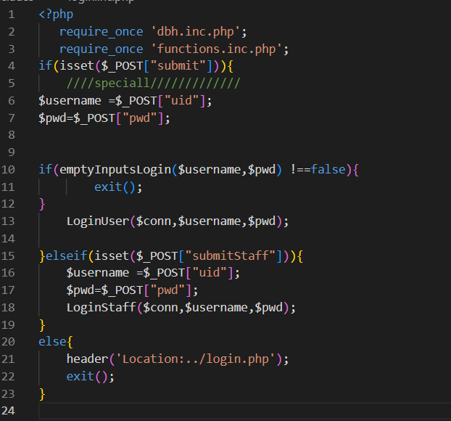

The login system in this code snippet allows both standard users and staff to log in. The $_POST method captures the input values (uid and pwd) from the login form, where the username and password are sent for validation through functions like emptyInputsLogin($username, $pwd) to check for empty fields. Once validated, the function LoginUser() or LoginStaff() interacts with the database to verify the credentials and initiate the session.

In the case of staff members, a similar process is followed. Depending on the form submission (submitStaff), the staff's username and password are validated, and their session is established.

This session management ensures that users and staff are correctly authenticated, and their data is securely retained during their session. If the login fails or the form inputs are incomplete, the user is redirected to the login page without initiating a session.

**Security Considerations**

* Session Variables are crucial in maintaining user states, allowing them to navigate across the website after logging in.
* Validation Functions ensure that the input is sanitized and errors are managed appropriately.
* The logout mechanism effectively ends the session and prevents unauthorized access after logging out by destroying the session and redirecting users to the homepage.

**File Inclusions and Dependencies**

The code begins by including two files using require_once: dbh.inc.php and functions.inc.php.

* dbh.inc.php likely contains the database connection logic, allowing the script to interact with the database to retrieve and validate user credentials.
* functions.inc.php likely contains utility functions that are reused throughout the login process, such as validation functions and login management.

**Handling Form Submissions**

The login process is initiated when a form is submitted. The script detects the type of form submission based on two POST variables:

* Regular User Login Submission: Detected via isset($_POST["submit"]).
* Staff Login Submission: Detected via isset($_POST["submitStaff"]).

**Login Flow for Regular Users**

* When the login form is submitted by a regular user, the username (uid) and password (pwd) are captured from the $_POST array.
* Input Validation: Before proceeding, the function emptyInputsLogin($username, $pwd) is called to check if either the username or password fields are empty. If this function returns true, the script stops further execution with exit() to prevent invalid data from being processed.
* Login User Function: If input validation passes, the LoginUser($conn, $username, $pwd) function is called. This function:
* Queries the database to verify if the username exists.
* Compares the password entered with the hashed password stored in the database.
* If credentials match, the user is logged in, and session variables are likely created to maintain the user's logged-in state.

**Login Flow for Staff**

* The login process for staff members follows a similar structure but is triggered by the submitStaff button.
* The staff's username and password are captured, validated through the emptyInputsLogin($username, $pwd) function, and then passed to the LoginStaff($conn, $username, $pwd) function.
* LoginStaff Function: This function performs similar actions to LoginUser, but with additional logic to ensure that only users with staff credentials can log in.

**Redirection**

If neither the submit nor submitStaff buttons are clicked, the script automatically redirects the user to the login page (../login.php) using the header() function. The exit() after the redirect ensures that no further code is executed once the redirection occurs.

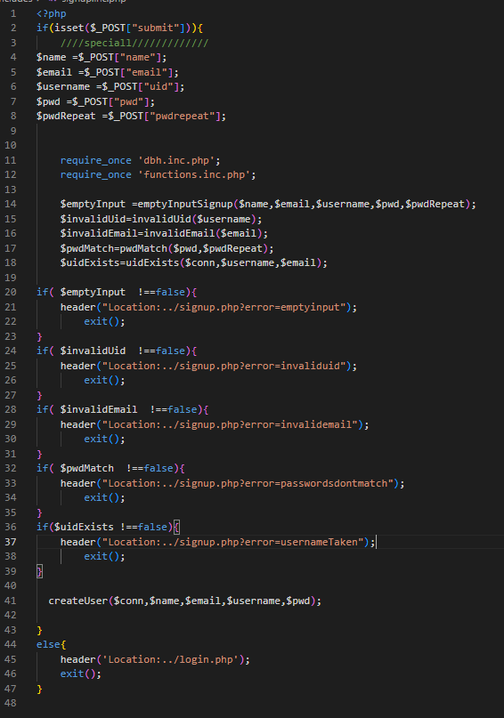**2.2.2 Register Process**

**User Registration Process**

This PHP script handles the user registration process, ensuring the provided information is validated and stored securely in a database. It performs a series of checks on the user’s inputs and handles errors accordingly. The process involves interacting with utility functions for validation, preparing SQL queries, and inserting the validated data into the database.

**Form Submission Handling**

The registration process starts when the form is submitted by detecting the POST method:

Form Fields: The form includes the following fields:

* name (Full Name)
* email (Email Address)
* uid (Username)
* pwd (Password)
* pwdRepeat (Password Confirmation)

The script captures the submitted data and assigns it to variables such as $name, $email, $username, $pwd, and $pwdRepeat.

**Required Files**

Two essential files are included using require_once:

* dbh.inc.php: Contains the database connection logic, allowing interaction with the database.
* functions.inc.php: Holds utility functions such as input validation, password checking, and user existence verification. These functions ensure that the form inputs are correctly formatted and valid.

**Validation Process**

The script performs several validation checks before proceeding with the registration:

1. **Empty Input Check:**

The function emptyInputSignup($name, $email, $username, $pwd, $pwdRepeat) verifies if any of the required fields are left empty. If so, the user is redirected to the signup page with an error message (emptyinput), and further execution is halted with exit().

1. **Invalid Username Check:**

The function invalidUid($username) checks if the username contains invalid characters. If it fails, the user is redirected with an invaliduid error.

1. **Invalid Email Format:**

The function invalidEmail($email) checks if the email is in the correct format. An error message invalidemail is displayed if the email format is incorrect.

1. **Password Match Validation:**

The pwdMatch($pwd, $pwdRepeat) function ensures that both the password and its confirmation match. If the passwords do not match, the user is redirected with a passwordsdontmatch error.

1. **Username or Email Already Exists:**

The uidExists($conn, $username, $email) function queries the database to check if the username or email address is already in use. If the function returns true, the user is notified with a usernameTaken error.

**User Creation Process**

If all validation checks are passed, the createUser($conn, $name, $email, $username, $pwd) function is called. This function is responsible for creating a new user in the database.

1. **Password Security:**

The password is securely hashed using a function like password_hash() before storing it in the database. This ensures that plain text passwords are not stored, increasing security against data breaches.

1. **Database Insertion:**

The createUser function prepares an SQL query to insert the user's details (name, email, username, and hashed password) into the database, ensuring the new user is added.

**Redirection and Error Handling**

* Successful Registration: If the user is successfully created in the database, the script redirects the user to the login page (../login.php).
* Form Not Submitted: If the form is not submitted correctly or accessed directly, the user is redirected back to the login page, maintaining secure access to the registration script.

**2.2.3 Connect to Database**

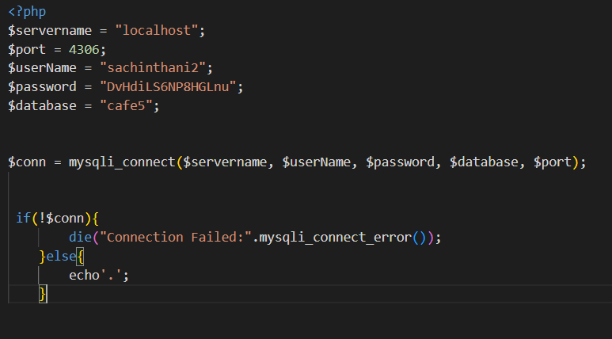

This PHP script establishes a connection to a MySQL database by defining the server details, user credentials, and database name. It ensures that the application can interact with the database for operations like retrieving, inserting, updating, and deleting data.

**1. Server and Database Details:**

The script begins by defining the necessary parameters for connecting to the database:

* $servername = "localhost"; specifies the server's address, which in this case is localhost, indicating the MySQL server is hosted on the same machine as the PHP script.
* $port = 4306; sets the port number for connecting to the MySQL server. In this setup, the server is running on port 4306.
* $userName = "sachinthani2"; provides the MySQL user name that has access to the cafe5 database.
* $password = "DvHdiLS6NP8HGLnu"; is the associated password for the MySQL user.
* $database = "cafe5"; specifies the name of the database to connect to, which in this case is cafe5.

**2. Establishing a Connection:**

The mysqli_connect() function is used to establish the connection:



* This function takes in five parameters: server name, username, password, database name, and port number, and returns a MySQLi connection object ($conn).
* If the connection is successful, the $conn object will contain the active connection to the database. If it fails, the object will return false.

**3. Error Handling:**

The connection is validated by checking if the $conn object is false:

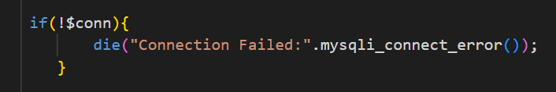

* If the connection fails, the script terminates with die(), and an error message is displayed. The error message includes the reason for the failure using mysqli_connect_error(), which provides detailed information about what went wrong during the connection process.

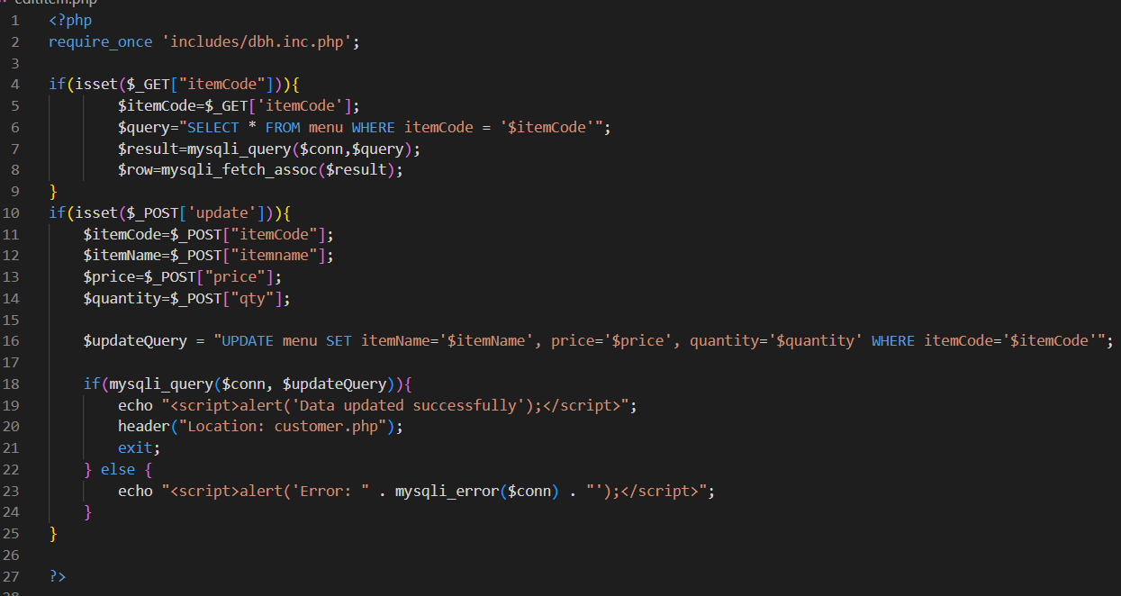**2.2.4 Update Records**

This PHP script manages the process of updating records in a MySQL database, specifically in the context of a restaurant menu management system. The script retrieves the current details of a menu item using the itemCode and allows for updating its itemName, price, and quantity.

**1. Database Connection**:

* The script starts by including the database connection file dbh.inc.php, which is essential for establishing a connection with the MySQL database:

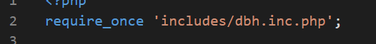

* The file dbh.inc.php contains the necessary credentials to connect to the MySQL database.

**2. Fetching Existing Data**:

* When the user accesses the page, the script checks for the presence of the itemCode in the URL using the $_GET method:

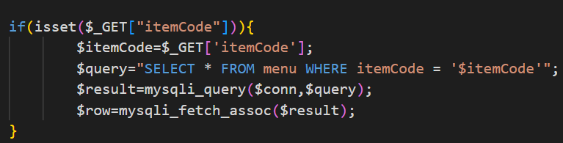

* Purpose: This block retrieves the current record for the specified itemCode from the menu table. It executes a SELECT query to fetch all details of the menu item using mysqli_query(), and the result is stored in the $row variable.
* The $row contains the existing details of the item, such as itemName, price, and quantity, which will be used to pre-fill the form for editing.

**3. Handling the Update Request**:

* Once the user submits the update form, the script handles the POST request by checking if the update button has been clicked:

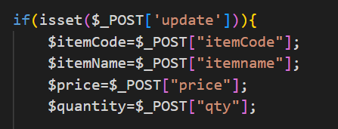

* Form Inputs: The updated values (itemCode, itemName, price, and quantity) are retrieved from the form via the $_POST array. These values represent the new details of the menu item.

**4. Executing the Update Query**:

* The script then constructs an UPDATE SQL query to modify the existing record in the menu table:
* Purpose: This query updates the itemName, price, and quantity fields in the database for the specific itemCode provided.
* The use of the WHERE itemCode='$itemCode' ensures that only the relevant record is updated based on its unique identifier (itemCode).

**5.** **Executing and Validating the Update**:

* The query is executed using mysqli_query():

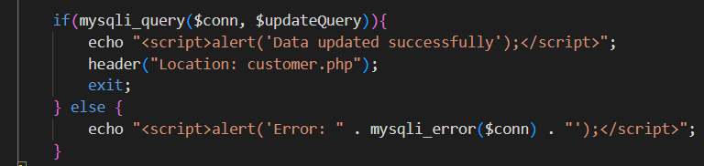

* Success Case: If the query executes successfully, the script shows an alert (Data updated successfully) and redirects the user to customer.php.
* Error Handling: If the update fails, an alert message is shown, displaying the specific error using mysqli_error($conn) to help with debugging.

**6. User Experience**:

* **Redirection**: After a successful update, the user is redirected to customer.php to view the updated record. This improves the flow of the application, allowing users to continue their operations without interruption.
* **Alerts**: The use of JavaScript alert() provides instant feedback to the user on whether the update was successful or if an error occurred, contributing to a more interactive user experience.
  + 1. **Deleting Records**

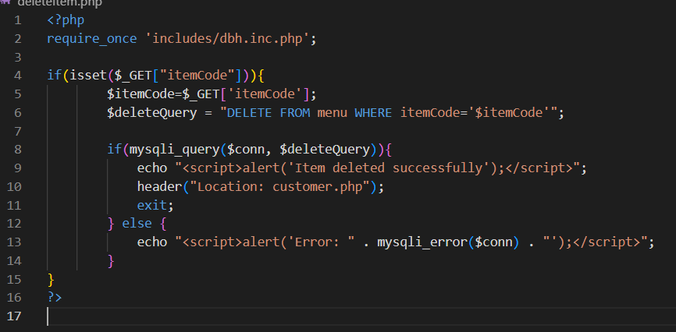

**1. Database Connection**:

* The script begins by including a file dbh.inc.php to establish a connection with the MySQL database:

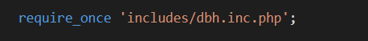

* This file contains the necessary connection parameters (host, username, password, database) that allow the script to communicate with the MySQL database.

**2. Retrieving the Item to Delete**:

* The script checks if the itemCode is present in the URL via the $_GET method:

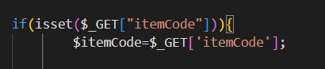

* **Purpose**: This step captures the unique itemCode for the menu item the user wishes to delete. The itemCode acts as the unique identifier for each item in the menu table.

**3. Executing the Delete Query**:

* Once the itemCode is retrieved, the script constructs a SQL DELETE query to remove the corresponding item from the database:

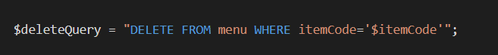

* **Purpose**: This query specifies that the record with the given itemCode will be removed from the menu table. The DELETE statement ensures that the specified row is permanently removed from the database.

**4. Executing and Validating the Deletion**:

* The script uses mysqli_query() to execute the deletion query:

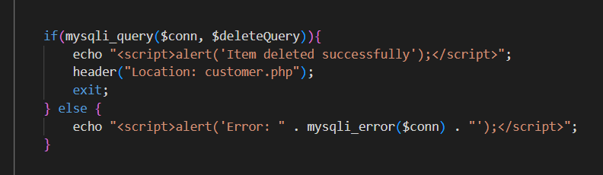

* **Success Case**: If the query executes successfully, a JavaScript alert is displayed to notify the user that the item has been deleted (Item deleted successfully). Afterward, the script redirects the user to the customer.php page, where they can view the updated list of menu items.

**Task 3**

1. **System Testing and Evaluation**

**Testing Overview**

**Objective**

The objective of this testing process is to ensure that the web application performs according to its functional requirements, is user-friendly, secure, and offers a reliable experience. The goal is to identify and resolve any defects or inconsistencies before deployment. This report will discuss a comprehensive approach to testing, utilizing both black-box and white-box testing techniques, alongside usability and performance testing.

**Scope**

The scope of the testing covers all core functionalities of the web application, including user authentication (login, registration), user interaction with the menu (viewing, searching, and ordering items), reservation and pre-order management, and administrative functionalities such as data manipulation (create, update, and delete operations). Testing will be done across all user roles (Admin, Operational Staff, and Customers) to ensure that each feature operates as expected. The testing will also focus on interface responsiveness, database consistency, and security protocols like input validation and session management.

**Test Plan Summary**

1. **Black-Box Testing:** **Objective:** The primary goal of black-box testing is to evaluate the application’s functionality without analysing its internal code structure. This method helps ensure that the user interface, workflows, and user experiences function according to specifications.

**Tested Scenarios:**

* + User login/registration processes for Admin, Operational Staff, and Customers.
  + Menu item search and filtering based on cuisine types.
  + Creation, update, and deletion of orders and reservations.
  + Interface responsiveness and form validation.
  + Error handling and user feedback on invalid inputs.

1. **White-Box Testing:** **Objective:** White-box testing aims to analyze the underlying code, ensuring optimal performance, security, and reliability. This involves testing algorithms, code paths, and internal structures.

**Tested Scenarios:**

* + Review of code for login, registration, and session management to identify potential vulnerabilities.
  + Database interaction testing for CRUD operations related to menu items, orders, and reservations.
  + Input validation to prevent SQL injection and cross-site scripting (XSS).
  + Testing database query efficiency and identifying performance bottlenecks.

1. **Usability Testing:** **Objective:** Assess the user experience (UX) of the web application, focusing on the ease of navigation, responsiveness, and overall satisfaction of the user interface.

**Tested Scenarios:**

* + Users’ ability to easily navigate between the menu, reservation system, and pre-ordering functionality.
  + Response time when searching for menu items.
  + User satisfaction feedback after interacting with the reservation and ordering system.

1. **Performance Testing:** **Objective:** Ensure that the application performs efficiently under various load conditions, particularly during peak times when multiple users are accessing the site concurrently.

**Tested Scenarios:**

* + Response times for user queries and database calls during high user traffic.
  + Scalability of the reservation system when processing multiple requests simultaneously.
  + Impact on performance when users upload files or perform data-heavy operations.

**Test Deliverables**

1. **Test Cases Documentation:** Detailed test cases will be prepared, documenting the expected and actual outcomes for all tested functionalities.
2. **Defect Reports:** Any identified bugs, vulnerabilities, or performance issues will be logged in a defect report, complete with error details and the steps needed to reproduce the issue.
3. **Test Summary Report:** After the completion of each test cycle, a summary report will be generated, outlining the pass/fail status of each test case and the overall health of the system.

**Test Cycle**

The testing process will follow a structured cycle, involving:

1. **Test Planning:** Define the scope, objectives, and schedule of the tests.
2. **Test Execution:** Run all planned tests and document results.
3. **Defect Reporting:** Log any issues that arise during testing, categorize them, and prioritize them for resolution.
4. **Resolution and Retesting:** Resolve defects and retest to confirm the fixes.
5. **Final Sign-off:** Once all tests pass successfully and the system meets all quality standards, the testing process will conclude.

**Test Tools**

1. **Black-Box Testing Tools:**
   * **Selenium:** For automating functional tests and ensuring that the user-facing features work as expected.
   * **Postman:** For testing APIs and ensuring smooth communication between the front-end and back-end.
   * **Browser Developer Tools:** To inspect live elements, test responsiveness, and debug front-end issues.
2. **White-Box Testing Tools:**
   * **PHPUnit:** For unit testing the PHP code to ensure that the internal logic of the application works as expected.
   * **OWASP ZAP:** To identify potential security vulnerabilities in the code, such as XSS or SQL injection risks.
   * **MySQL Workbench:** To evaluate the database schema, review query performance, and ensure data consistency.

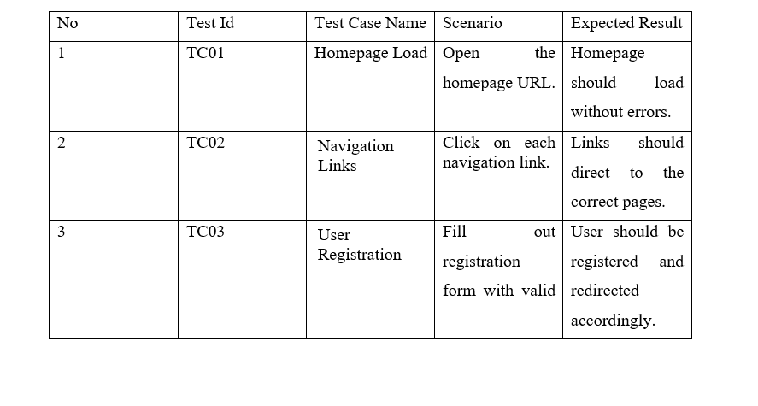

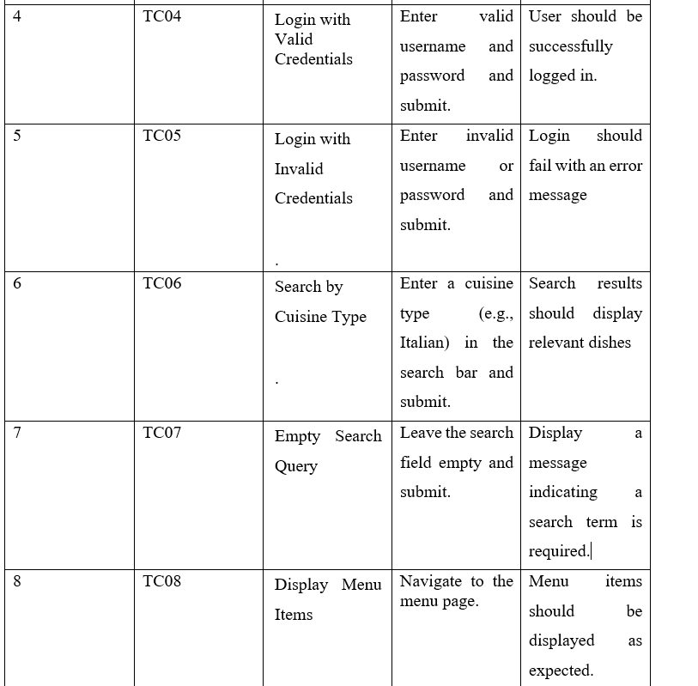

**Test Case**

|  |  |
| --- | --- |
| Test case ID | TC01 |
| Test objectives | Verify that the homepage loads correctly. |
| Test data | Open the homepage URL |
| Expected result | Home page should load without errors. |
| Actual result | Same as expected |
| Screenshot |  |
| Conclusion | This works properly. |

|  |  |
| --- | --- |
| Test case ID | TC02 |
| Test objectives | Verify the login |
| Test data | Input username or password that is not saved in the database |
| Expected result | Display “"Login failed. Invalid credentials.” |
| Actual result | Same as expected result |
| Screenshot |  |
| Conclusion | This works properly. |

|  |  |
| --- | --- |
| Test case ID | TC03 |
| Test objectives | Verify successful user registration |
| Test data | Fill out the registration form with valid details and submit |
| Expected result | User should be registered successfully and redirected accordingly |
| Actual result | Same as the expected result |
| Screenshot |  |
| Conclusion | This works properly. |

|  |  |
| --- | --- |
| Test case ID | TC04 |
| Test objectives | Check login function with valid credentials. |
| Test data | Input valid username and password |
| Expected result | User should be successfully logged in. |
| Actual result | Same as expected result |
| Screen shot |  |
| Conclusion | This works properly. |

|  |  |
| --- | --- |
| Test case ID | TC05 |
| Test objectives | Check user login failure |
| Test data | Input username or password that not are save in file |
| Expected result | Display “"Login failed. Invalid credentials.” |
| Actual result | Same as expected result |
| Screen shot |  |
| Conclusion | This works properly. |

|  |  |
| --- | --- |
| Test case ID | TC06 |
| Test objectives | Test search functionality by cuisine type |
| Test data | Enter a cuisine type in the search bar.(e.g., Italian) |
| Expected result | Should display relevant dishes. |
| Actual result | Same as expected result |
| Screen shot |  |
| Conclusion | This works properly. |

